**CTF Challenge: Using DNSSEC Debugger by Verisign Labs**

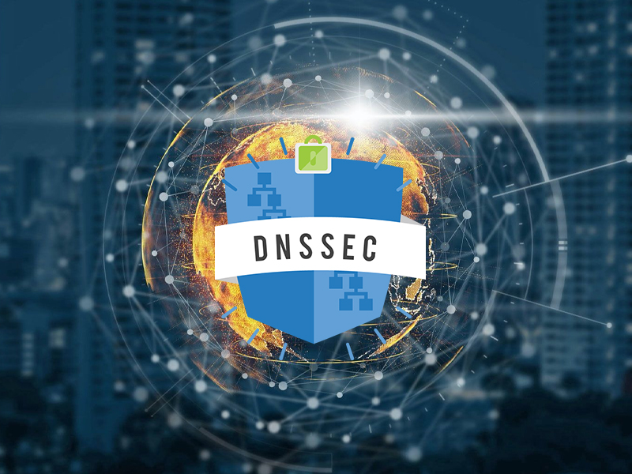

**1. Introduction**

DNSSEC Debugger by Verisign Labs is a tool that helps you diagnose issues with DNSSEC (Domain Name System Security Extensions) configurations for a domain. This challenge will introduce you to DNSSEC Debugger to gather information about the DNSSEC configuration and identify any potential issues.



**2. Tools and Requirements**

Access to the internet

Access to DNSSEC Debugger by Verisign Labs

**3. Scenario**

You are a website administrator responsible for the security of your company's online presence. Your task is to use DNSSEC Debugger to assess the DNSSEC configuration of your domain and ensure it is correctly set up to prevent security vulnerabilities.

**4. Process to Follow While Performing CTF**

Step 1: Go to DNSSEC Debugger by Verisign Labs:

[**https://dnssec-debugger.verisignlabs.com/**](https://dnssec-debugger.verisignlabs.com/)

Step 2: Enter the Domain Name **foodmandu.com** in the search bar and Enter

Step 3: Solve the CTF.

**5. Let’s Begin the Challenge**

**Questions**

Flag 1: How many DNSKEY records are found for the root zone?

Answer: 3

Flag Captured

Flag 2: How many RRSIGs are found for foodmandu.com?

Answer: No

Flag Captured

**Hint:**



